Merlin Suits
1665 Lexington Ave Suite 105 - Deland, FL 32724
Phone: (386) 738-2962
www.merlinsuits.com e-mail: info@merlinsuits.com

SIZING INFORMATION 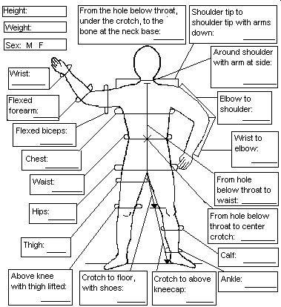
SPECIAL INSTRUCTIONS:

CUSTOMER INFO
Dealer (if applicable):___________________________
Name:_________________________________________
Address:______________________________________
City:__________________State/Zip:_______________
Country:______________Tel:_____________________ Email:_________________________________________

OPTIONS
- Cordura Booties $65.00
- Inseam Grips $20.00
- Reversed zip/black $ N/C
- Slip-ons/w. suit $22.00

RW SUITS
Gripper Size
- Regular
- Competition
- Pro Comp $20.00
- Two colored grips $10.00
- Cordura bum/knees $26.00
❑ Bum or  Knees $13.00 ea
❑ High Collar $20.00
around neck measure:_____

❑ Full Leather Toes $12.00
❑ Padded Knees $22.00
❑ Heavy Pads $30.00


Pro Comp RW Suit* $ 455.00

Comp RW Suit* $ 405.00

RW Suit $ 305.00
- Slow Suit $ 305.00

Options $_______

Subtotal $_______

Tax (FL6.5%) $_______

Shipping $25.00 $_______

ProComp/shipping $30.00

Call for intl. shipping

RUSH $75.00, call for availability.

TOTAL $_______
* Comp and Pro Comp Suits are priced with options included. See a list of the included options on the following page.
Front
_____________
Legs
_____________
Upper Back
_____________
Back Spandex
_____________
Sides
_____________
Forearms
_____________
Collar
_____________
Grips
______ /______
Front Back
Trim Tape
_____________

Nylon
Supplex
Spandex

Spandex
Supplex
Comp Suit includes: cordura booties, cordura grips, inseam grips, comp size grips, cordura bum, padded knees.

Pro Comp Suit includes all of the above plus: reinforcing on upper back and legs, double spandex sides, deeper and larger grips, Pro Comp booties, full leather toes, cordura reinforced crotch area.

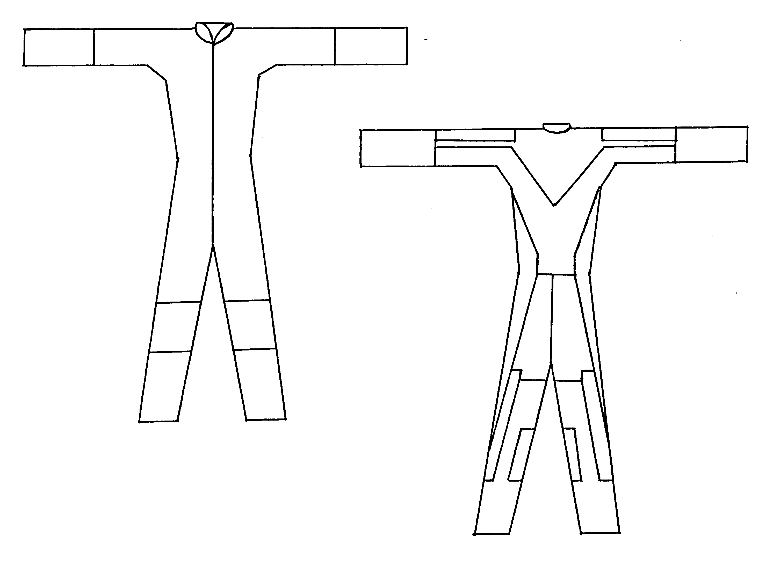
- Stripes___________________$30.00
- W/Piping_________________ $15.00
- Grip Piping*______________$25.00
*(grip piping along seam of grips)

