Merlin Suits
1665 Lexington Ave Suite 105 - Deland, FL 32724
Phone / Fax (386) 738-2962
www.merlinsuits.com e-mail: info@merlinsuits.com

OPTIONS
- Grips pr set $20.00
- Cordura bottom legs $15.00
- Heavy lined legs $10.00



CUSTOMER INFO
Dealer (if applicable):___________________________
Name:______________________________________________
Address:__________________________________________
City:__________________State/Zip:__________________
Country:______________Tel:________________________
Email:

SIZING INFORMATION 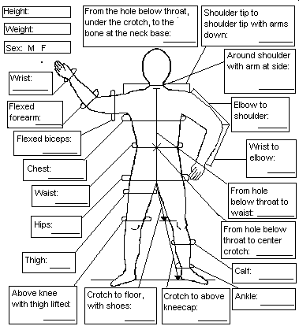

- 1 Stripe* $20.00
- 2 Stripes* $25.00
- 3 Stripes* $30.00
- Piping, per edge* $ 5.00

❑ Cordura bum/knees $26.00
❑ Bum  Knees $13.00ea
- Padded Knees $22.00
- Full leather toes/RW $12.00

- Fast Fall* Check desired
- Md. Fall* fall rate.
- Slow Fall*
* for Free Fly pants only

- Swoop Pants $ 185.00
- FreeFly Pants $ 185.00
- Bootie Pants $ 235.00

Options $_______
Subtotal $_______
Tax (FL6.5%) $_______
Shipping $18 $_______
(Call for International rates)

RUSH $75, call for availability.
TOTAL $_______

SPECIAL INSTRUCTIONS

PANTS

