Merlin Suits
1665 Lexington Ave., Suite 105 - Deland, FL 32724
Phone / Fax (386) 738-2962
www.merlinsuits.com e-mail: info@merlinsuits.com

OPTIONS
- Reg grips, per pair $20.00
- Flat grips, per pair $22.00
- Tunnel zipper/black $ N/C
- Grips (per pair) $18.00
- Heavy lined/arms/legs $15.00

Free-Fly Suit* $ 325.00 Options $_______ Subtotal $_______ Tax (FL. 6.5%) $_______ Shipping $25.00 $_______
(call for International rates)
RUSH $75, call for availability
TOTAL $_______

- 1 Stripes* $35.00
- 2 Stripes* $45.00
- 3 Stripes* $55.00
- Piping* per edge $ 5.00

❑ Cordura bum/knees $26.00
❑ Bum or  Knees $13.00 ea
- High Collar $20.00
Around neck measure:________

- Regular-wings $65.00
- Hybrid wings $70.00
- RSL shackles $28.00

- Fast fall Check desired
- Medium fall fall rate.
- Slow fall

Free-Fly Suit
SPECIAL INSTRUCTIONS

SIZING INFORMATION


CUSTOMER INFO
Dealer (if applicable):___________________________
Name:_________________________________________
Address:______________________________________
City:__________________State/Zip:_______________
Country:______________Tel:_____________________
Email:_____________________________________

Colors

Suit:____________________
Collar:__________________

Wrist Cuff:______________
Leg Cuff:________________
Grips: _________/_________
Grip tape: _______________

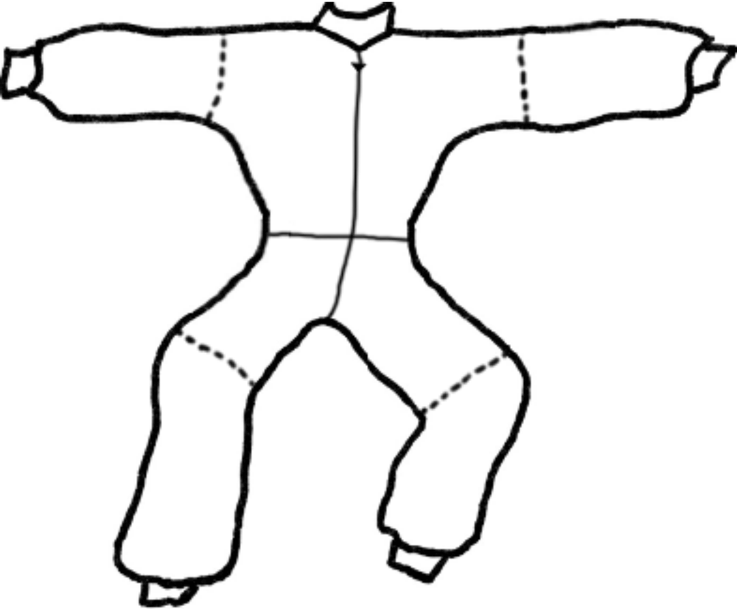

*Options:
1 stripe, color: ____________________
2 stripes, colors: __________________
3 stripes, colors: __________________
Piping, color: _____________________

